2.3 DATA FLOW DIAGRAM

A data flow diagram is a representation of how the information flows in a system. It also gives insight into the inputs and outputs of each entity and the process itself. The DFD is also known as a data flow graph or bubble chart.

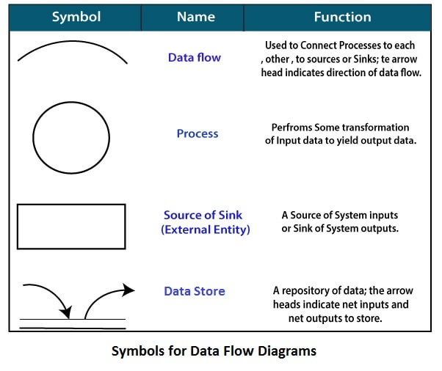

**2.3.1** Level-0 Data flow diagram of **Noteffy** 

Graphical representation of score on tasks completed

Regular notifications/ reminders for user’s tasks

Notes and tasks

User (authentication) data

2.3.2 Level-1 Data flow diagram of **Noteffy**

Mailing user to notify him

Calculating priority to know the tasks user should get notification about

Getting user email to send mail

Adding new user

**Storing user data**

Login of old user

Encryption / decryption of user’s data

Using API to create graph

**Maintaining record of completed tasks**

Sharing task/note

Completed tasks

Shifting task to to-do list If the completion date for task matches with current date

Deleting task/note

Editing task/note

Creating new task/note +

Priority of tasks

**Storing task/note**

Checking priority of tasks